8 – 28 – 17

Hi, Parents!

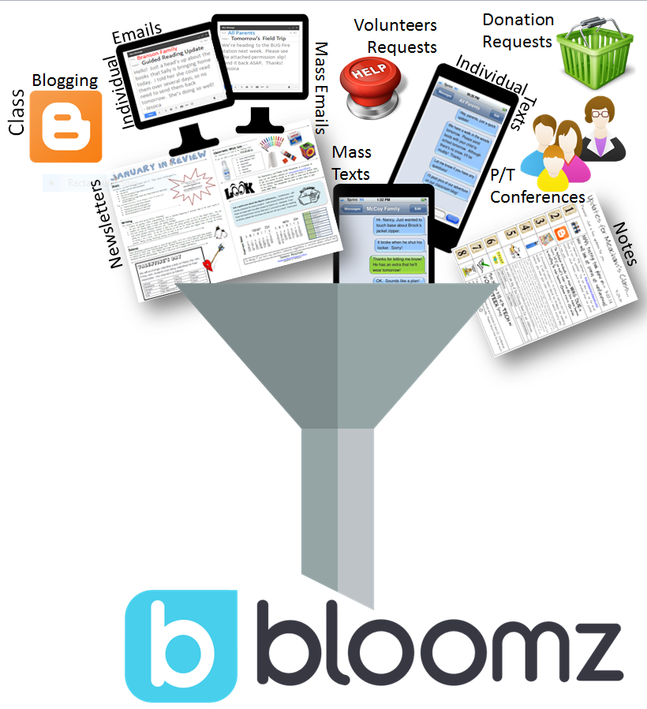
Want to hear something really cool? This year our class will utilize the Bloomz parent communication app. It’s an all-in-one app that gives you all communications digitally. Traditionally, when I communicate with parents I would use one of the following methods:

- Monthly Newsletter
- Weekly Blog Posts
- Random Notes Home
- Mass Emails
- Mass Texts

These traditional methods of communication were important because they gave parents insight into their child’s days, notified parents of volunteer opportunities and classroom wish list items that were needed; they also gave parents a heads up on random news and announcements that happened between newsletter and blog post updates. While they were a good way to keep parents informed, I found a BETTER way!
It’s the Bloomz app.

With Bloomz, I’ll share:

- Updates on what your child is doing and learning
- Photos and videos from classroom activities
- School and classroom events
- Invitation requests to special events
- Volunteer requests
- Parent/teacher conference signups
- And more…!

Imagine having access to all teacher communication in one spot -- your mobile device and/or computer! You’ll be notified when I add events, photos, and other things to our Bloomz classroom page. Notification preferences are decided by you! On the reverse side of this sheet, I share options for you to consider when you decide to join our Bloomz class.

To join our Bloomz class, you’ll need our Class Code =
1st- Decide how much interaction and engagement you’d like with our class on Bloomz.
2nd – Join our class via the notification method that most closely relates to how much interaction you’d like.
Web Browser | Smartphone App | Cell Phone SMS Text
I want to see AND  be able to respond to: | I want to see AND  be able to respond to: | I want to be able to see, but not respond to:
- Posts/News/Updates  - Instant Messages  - Pictures and Videos  - Links and Documents  - Events/Calendar  - Volunteer Requests  - Classroom Need Requests  - Student {Portfolio} Timelines  - Student Behavior Reward Points  - P/T Conference Sign Ups | - Posts  - Instant Messages  - Pictures and Videos  - Links and Documents  - Events/Calendar  - Volunteer Requests  - Classroom Need Requests  - Student {Portfolio} Timelines  - Student Behavior Reward Points  - P/T Conference Sign Ups | - Posts  - Instant Messages  - Pictures and Videos  - Links and Documents  - Events/Calendar  - Volunteer Requests  - Classroom Need Requests
To Join:  Use our class code to sign on/join using your laptop or computer. | To Join:  Download the Bloomz app. Use our class code to sign on/join using your smartphone. | To Join:  Use your cell phone to text Bloomz. Enter our class code.
You’ll get email notifications. | You’ll get app push notifications. | You’ll get SMS text notifications.

Frequent Parent Questions:

Should both mom and dad join the class? | That’s completely up to you. Last year we had a combination of both. For some families, only one parent signed on, while other families had both parents join.
How often will we get notifications? | I try to keep the notifications down to one per day, but some days are a little busier than others. Some days you won’t be notified at all. On average you’ll be notified 5-6 times per week.
Will I be able to communicate with other parents on Bloomz? | Yes! When you start an instant message with another parent or a few parents, it is completely private and other parents cannot see. It’s similar to Facebook chat. Parents often use private chat with other parents to:  - Plan play dates  - Get addresses for birthday invites
Is there a parent help section? | Yes! https://bloomz.desk.com/
Let’s connect on Bloomz!
Tiffany Bowers

